EE052
PRINCIPLES OF EE1 LAB

Lab 1

Introduction to
Electric Circuit Laboratory

Full name: Đinh Vũ Hoàng Minh, Nguyễn Tuấn Đạt
Student number: EEACIU22165, EEACIU22
Class: S2_2023-24_G02
Date: 1/5/2024

OBJECTIVES
In this laboratory, you will be introduced:
- Lab schedule and policies.
- The use of breadboard.
- How to read resistor color codes and capacitor codes.
- The equipment will be used during this laboratory.

INTRODUCTION TO ELECTRIC CIRCUIT
- Lab Schedule

Lab No. | Date | Report Due | Topic
1 | Week 3 |  | Introduction to electric circuit laboratory
2 | Week 4 |  | Introduction to MultiSim Electronic Workbench
3 | Week 5 |  | Kirchoff’s current and voltage laws
4 | Week 6 |  | Frequency and phase shift measurement
5 | Week 7 |  | Thevenin’s theorem for AC circuits
6 | Week 9 |  | Mesh and nodal analysis of AC circuits
7 | Week 10 |  | Operational Amplifiers
8 | Week 11 |  | Circuits utilizing op-amps

- Lab Reports and Grading
Students are required to turn in a Pre-Lab report before each lab session, and a Lab Report per experiment. The Pre-Lab report includes the calculation and simulation parts. You are not allowed to do the lab without your Pre-Lab report. The due date for each Lab Report is posted in the class schedule above.
Each lab report is 100 points that will be distributed as follows:
Pre-lab: 30 points.
Lab report: 70 points.
As shown above, 30% of the lab's final grade is deducted if the student fails to complete the pre-labs. 70% of the lab's final grade is based on your lab operation and the written post-lab report. Even though you are working in teamwork, you have to turn in your lab report individually with your own calculation and explanation. When applicable, late reports have a 10% grade deduction per delayed day. The final grade is the average of all the graded items in the course.
- Lab Policies
  - Important Notes: Read carefully the following points:
- The students should be prepared on the theoretical material of the lab topic.
- Be prepared to answer questions.
- Prepare previously all Pre-Lab calculation and simulation to avoid a 30% deduction from the lab report grade.
- There is no make-up lab. Not attending a lab implies that the student has no grade for that lab.
- The presentation of a previous year's or someone else's lab is considered cheating.
- The penalty for cheating on any graded item is an automatic zero in the course.
  - Instruments and supplies, the major instruments you will need are permanently installed in the stations. A selection of wires, cables and connectors are inside your kit. Small parts (resistors, capacitors, transistors, ICs) will be available in the bins in the lab area. They can be reused and should be left on the table in the same manner as they were obtained.
  - Leave your workplace at least as clean and tidy as you found it. Put everything back in its proper place. If the workplace is not tidy after you finish, it will cause to lose some points.
  - Precautions. Electronic test equipment can be damaged if incorrectly used.
- The function generator will be damaged if a large DC or AC voltage is applied to the outputs.
- The oscilloscope also has input limitations. Do not exceed 300V on any oscilloscope input.
- Power supplies can also be damaged if an external voltage in excess of the supply output voltage is fed back into the supply.
- The most common ways multi-meters are damaged are by trying to measure voltage when the meter is set to measure current or resistance or by exceeding the maximum voltage when in the voltage measurement mode. Think twice before connecting a meter. In particular, check the position of the function switch and ensure the test leads are connected to the proper inputs on the meter. If you make a mistake you could blow the meter’s internal fuse or damage the converter chip.
  - No foods or drinks are allowed inside the lab for any reason.
- Breadboard
- Uses of breadboard

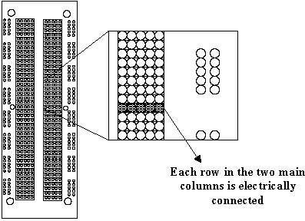

Figure 1
A breadboard is used to make up temporary circuits for testing or to try out an idea. No soldering is required so it is easy to change connections and replace components. Parts will not be damaged so they will be available to re-use afterwards.
- Connections on breadboard
Breadboards have many tiny sockets (called 'holes') arranged on a 0.1" grid. The leads of most components can be pushed straight into the holes. ICs are inserted across the central gap with their notch or dot to the left.
Wire links can be made with single-core plastic-coated wire of 0.6mm diameter (the standard size). Stranded wire is not suitable because it will crumple when pushed into a hole and it may damage the board if strands break off.
The diagram shows how the breadboard holes are connected:
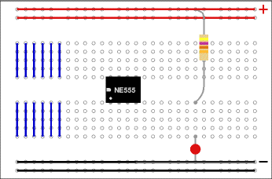
Figure 2
The top and bottom rows are linked horizontally all the way across as shown by the red and black lines on the diagram. The power supply is connected to these rows, + at the top and 0V (zero volts) at the bottom.
The other holes are linked vertically in blocks of 5 with no link across the centre as shown by the blue lines on the diagram. Notice how there are separate blocks of connections to each pin of ICs.
- Building a circuit on breadboard

Making a connection between two components is simple once you understand the internal wiring of the board. Let’s take a simple example of connected two resistors in series or in parallel. The general wiring fabric of the breadboard provides an unlimited number of possibilities, but we want to focus on the efficient implementations. Never use more jumper wire than necessary! Let the breadboard do the work for you.

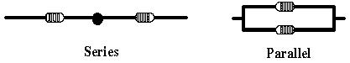
Figure 3

Figure below shows 3 examples of series wiring and 2 examples of parallel wiring. The pinholes where the component leads connect to the board are exaggerated with big circles.
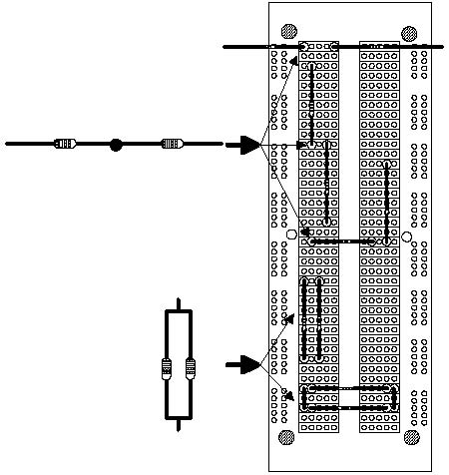
Figure 4

A few general points to remember when you begin wiring a circuit:
- Try to use the breadboard to make connections, i.e. avoid the use of extra jumper wire. It is said that the more wire you use, the more likely you are to make an error by shorting two wires or incorrectly wiring the circuit.
- When you use extra jumper wire, keep it as short as possible. If your circuit looks like a bush of wires, imagine how hard it will be to debug it when it doesn’t work correctly.
- Keep related components together.
- Make the circuit on the breadboard look as much as possible like the schematic you’re implementing. The visual correspondence will help you differentiate the various nodes; plus, your TA can do more to help you debug if he can easily make sense of your circuit.
Finally...
- Check all the connections carefully.
- Check that parts are the correct way round (for example: LED or 100µF capacitor).
- Check that no leads are touching (unless they connect to the same block).
- Connect the breadboard to a power supply and press the push switch to test the circuit.
- If your circuit does not work, disconnect (or switch off) the power supply and very carefully re-check every connection against the circuit diagram.

- Resistor Color Codes

The code

Black | Brown | Red | Orange | Yellow | Green | Blue | Violet | Gray | White
0 | 1 | 2 | 3 | 4 | 5 | 6 | 7 | 8 | 9


How to read the code
- First find the tolerance band, it will typically be gold (5%) and sometimes silver (10%).
- Starting from the other end, identify the first band - write down the number associated with that color; in this case Blue is 6.
- Now 'read' the next color, here it is red so write down a '2' next to the six. (You should have '62' so far.)
- Now read the third or 'multiplier' band and write down that number of zeros.
- In this example it is two so we get '6200' or '6,200'. If the 'multiplier' band is Black (for zero) don't write any zeros down. If the 'multiplier' band is Gold move the decimal point one to the left. If the 'multiplier' band is Silver move the decimal point two places to the left. If the resistor has one more band past the tolerance band it is a quality band.

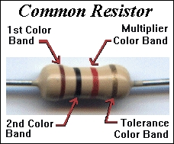
Figure 5

Practice

4700 ohm, 5% = yellow violet red, gold | 10M, 10% =
100 ohm, 2% = brown black brown, red | 4.7 ohm, 10% =
1000 ohm, 5% = brown black red, gold | 1K2, 5% =
22 ohm, 1% = red red black, brown | 6800 ohm, 10% =
150 ohm, 5% = | 56K, 5% =
270 ohm, 5% = | 1K, 5% =
- Capacitor Codes
Large capacitor have the value printed plainly on them, such as 10 µF (Ten Micro Farads) but smaller disk types along with plastic film types often have just two or three numbers on them.
Most will have three numbers, but sometimes there are just two numbers. If there are 2 numbers, these are read as Pico-Farads. An example: 47 printed on a small disk can be assumed to be 47 Pico-Farads.
What about the three numbers? It is somewhat similar to the resistor code. The first two are the 1st and 2nd significant digits and the third is a multiplier code. The multiplier code is listed in the table below, which is different from which of resistor.
Digit Multipliers
Third digit | Multiplier  (The first two digit gives you the value in pico-Farads)
0 | 1
1 | 10
2 | 100
3 | 1,000
4 | 10,000
5 | 100,000
6 | Not used
7 | Not used
8 | .01
9 | .1

For an example: A capacitor marked 104 is 10 with 4 more zeros or 100,000pF which is otherwise referred to as a .1 µF capacitor.

EQUIPMENT AND PARTS LIST

Function Generator

Oscilloscope

Digital Multi-Meter

PROCEDURES
1. Measure Voltage Differences
Build the simple circuit shown, Vi = 5(V) (DC voltage), then measure the amplitude of the signals at A and B with respect to ground.
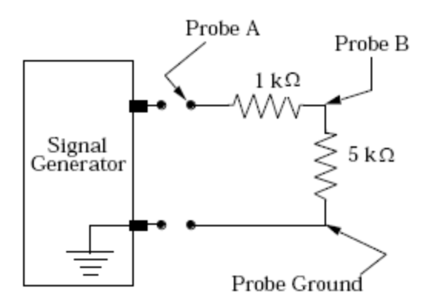

Figure 6

2. Voltage Divider
Display the signal generator output, note its amplitude, then connect the1k potentiometer as shown. Connect the B probe to the sliding output of the potentiometer.
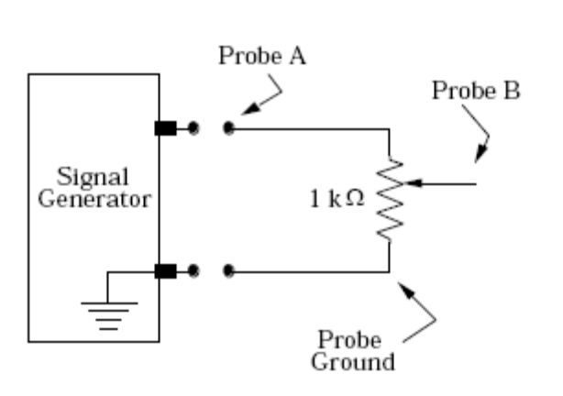
Figure 7

  - Why does the A signal become smaller when the potentiometer is connected?
  - Describe how the B signal amplitude varies with the potentiometer setting
3. Investigate a Current Divider
Build the current divider shown below, using R1 = 10k, R2 = 22k, and a potentiometer R3 = 10 k or a similar value.
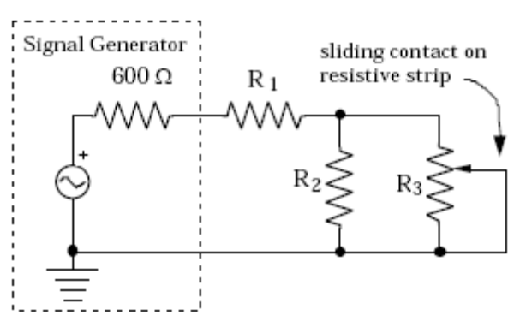
Figure 8

  - With the potentiometer set so that the maximum resistance is in the circuit, measure the voltages, vA and vB, and use Ohm's law to calculate the currents inR1, R2. and the in-circuit part of R3. Write algebraic expressions for the currents before using the actual component values.
vA = vB =
i1 = i2 = i3 =
  - Reduce the potentiometer to about one-quarter of its maximum setting (just estimate this from the knob rotation), and again measure the voltages and calculate i3 with the assumption that R3 is one-quarter of its maximum value
vA = vB = i3 =
  - Draw the schematic when the potentiometer R3 is set to zero Ohms in the circuit. Simplify your sketch by removing branches that carry no current, then calculate the current through sliding contact.

Lab report 1:
1/
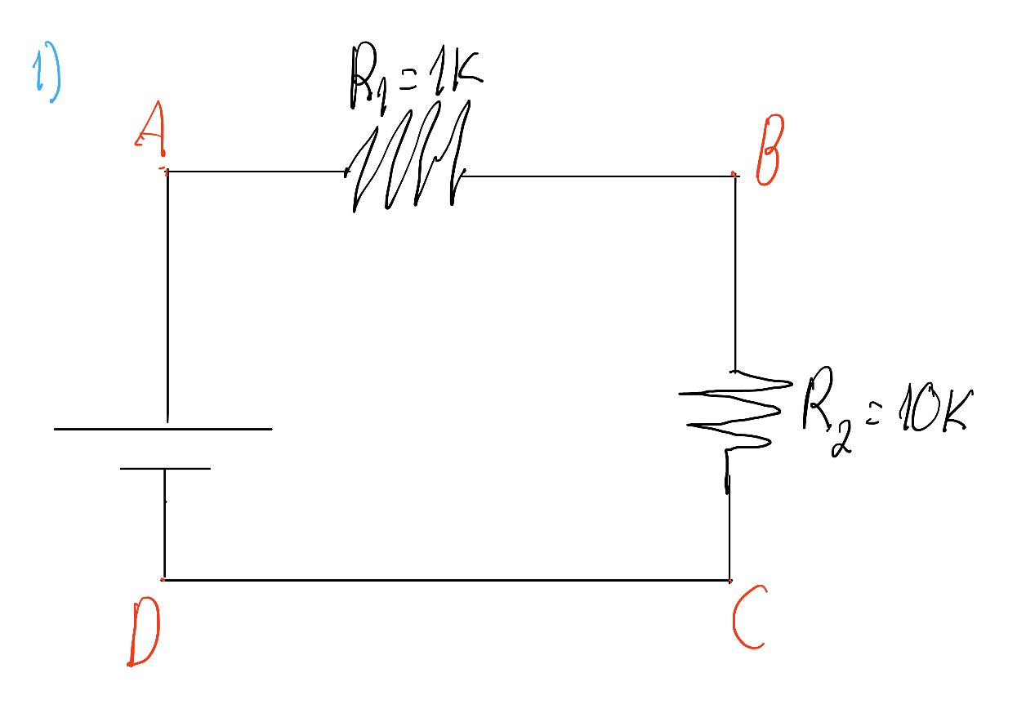
 | V_{AB} | V_{BC} | V_{CD} | V_{AD} | V_{CB}
Calculation | 0.4545 | 4.5454 | 0 | 5 | -4.5454
Measurement | 0.4519 | 4.541 | 0 | 4.994 | -4.541
Error(%) | -0.57 | -0.096 | 0 | -0.12 | -0.096
2/

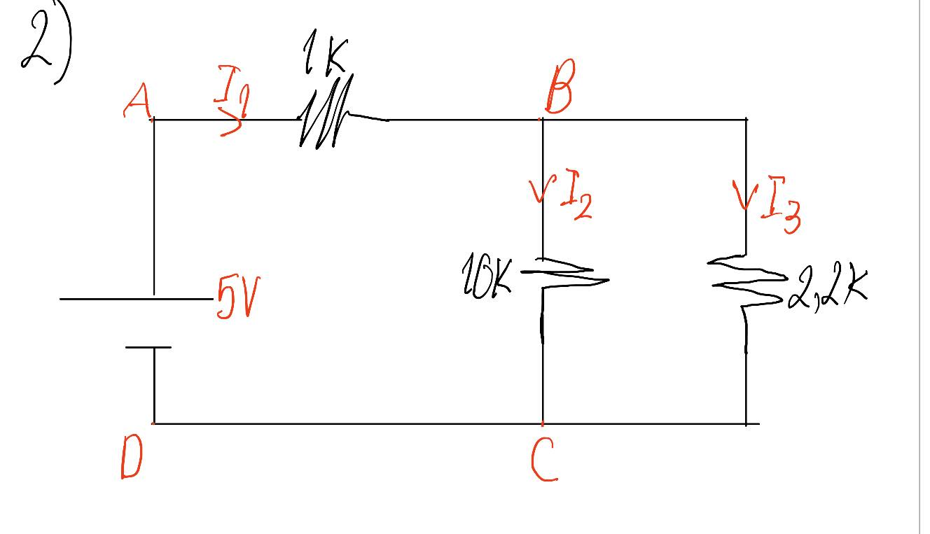
 | V_{AB} | V_{BC} | I₁ | I₂ | I₃
Calculation | 1.78 | 3.21 | 0.00178 | 0.000322 | 0.001463
Measurement | 1.7636 | 3.23 | 0.00176 | 0.000323 | 0.001468
Error(%) | -0.92 | 0.623 | -1.12 | 0.310 | 0.341
3/

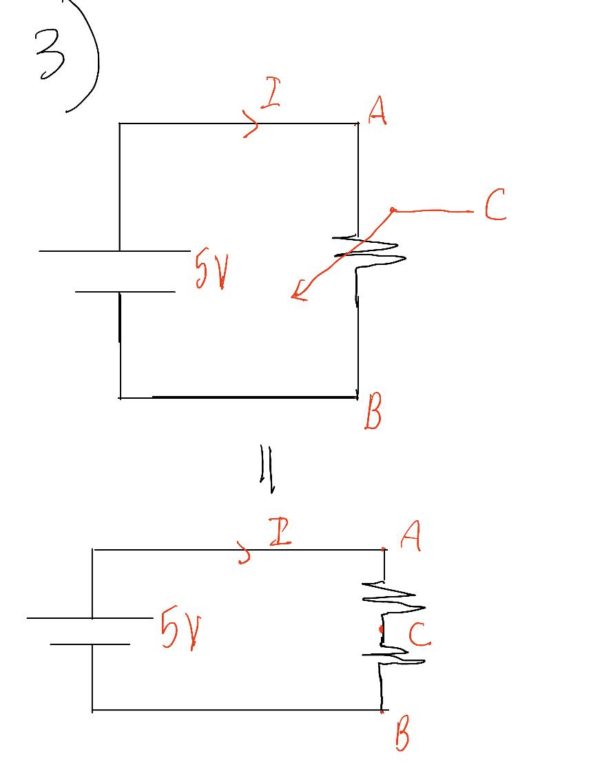
R_{AC} | 2K | 10K | 15K
V_{AC} | 0.5 | 2.5 | 3.75
V_{CB} | 4.5 | 2.5 | 1.25

4/

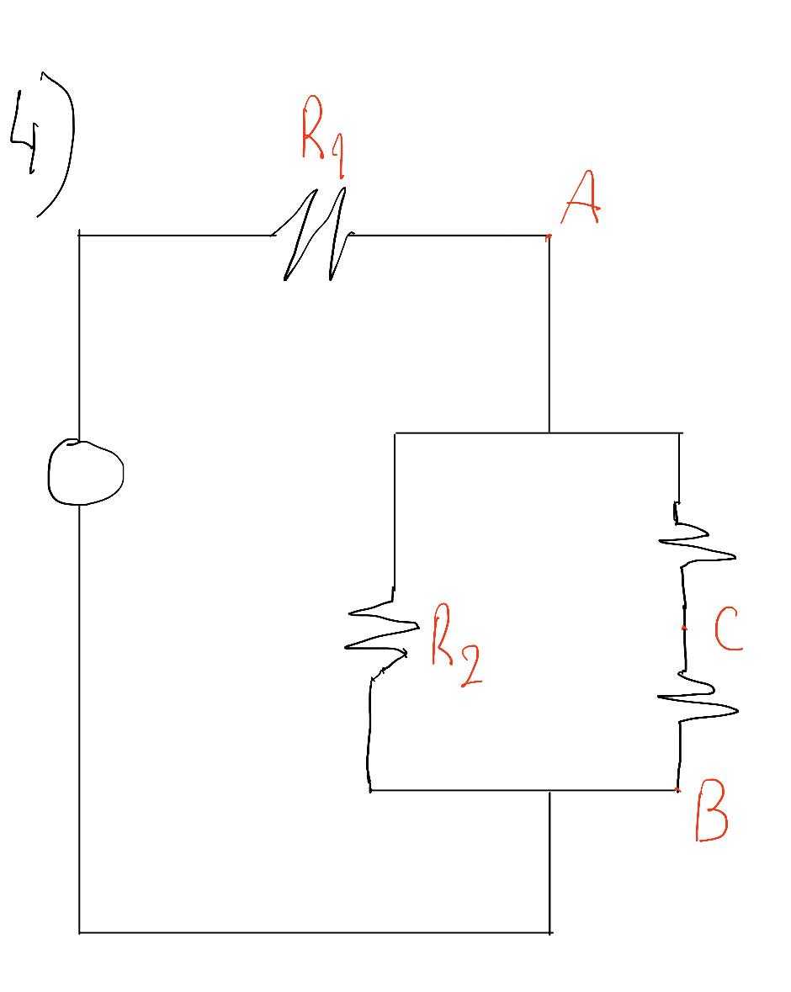
R_{AC} | 2K | 5K | 10K
V_{AC} | 0.407 | 1.018 | 2.037
V_{CB} | 1.63 | 1.019 | 0

